# RAP-05-Setup For RAP and Development

<https://youtu.be/seKRCwG8Aso?list=PLqz8SLrkjv2iwPtPRJ4V6zJRfgNrgZKlQ>

## Prerequisites start with RAP:

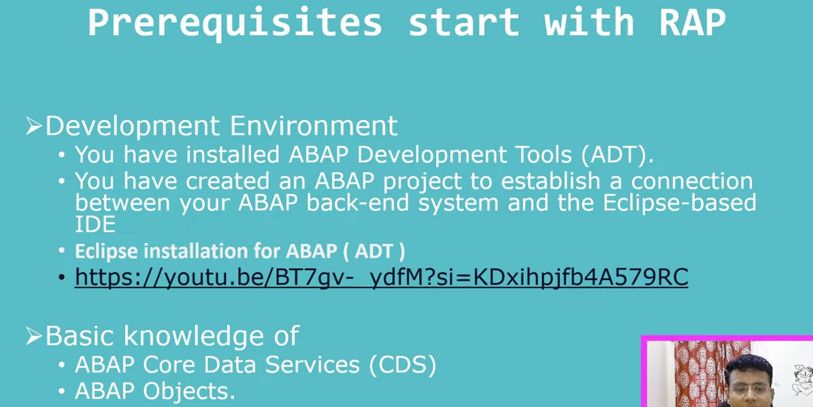

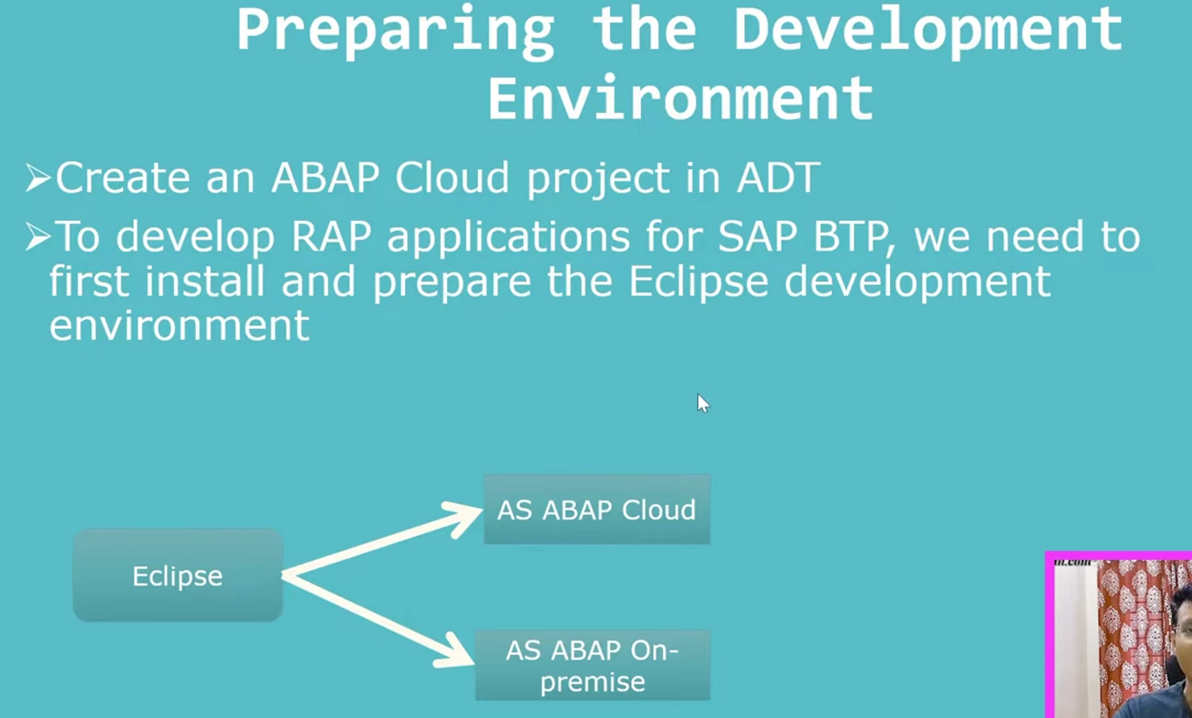

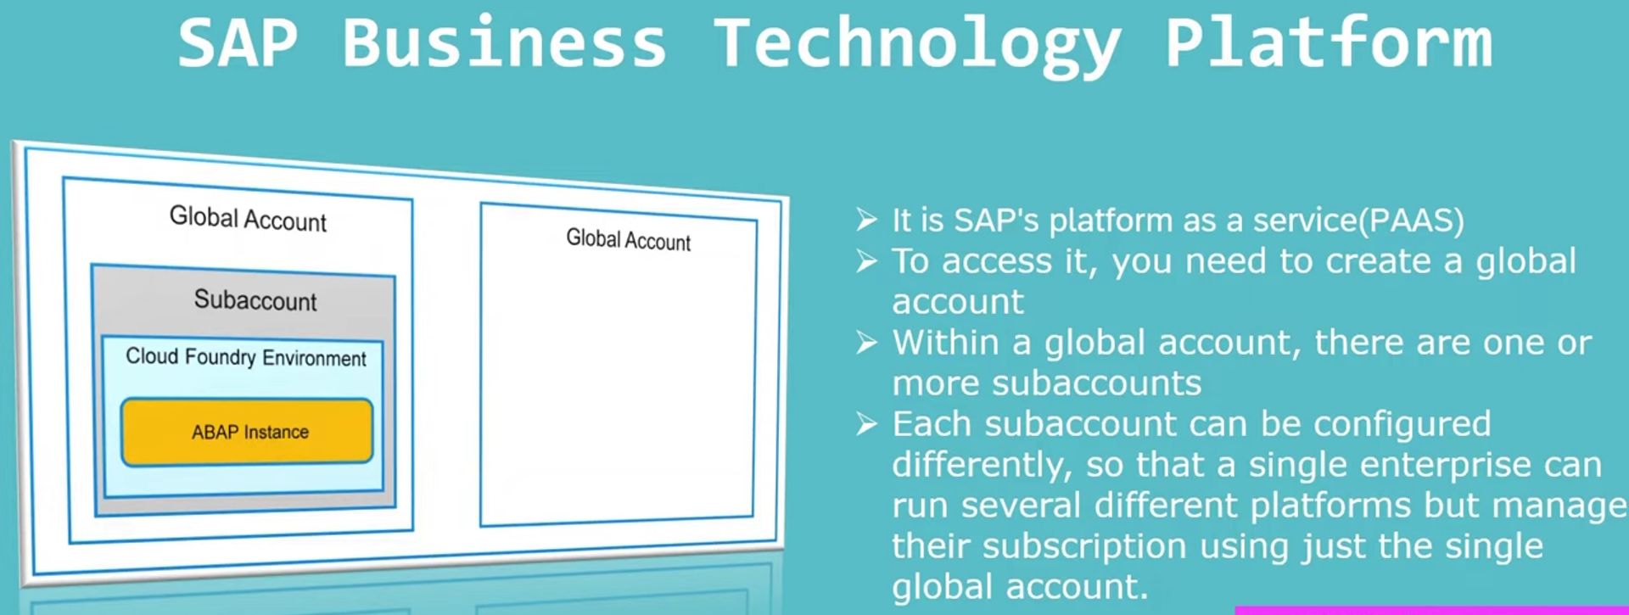

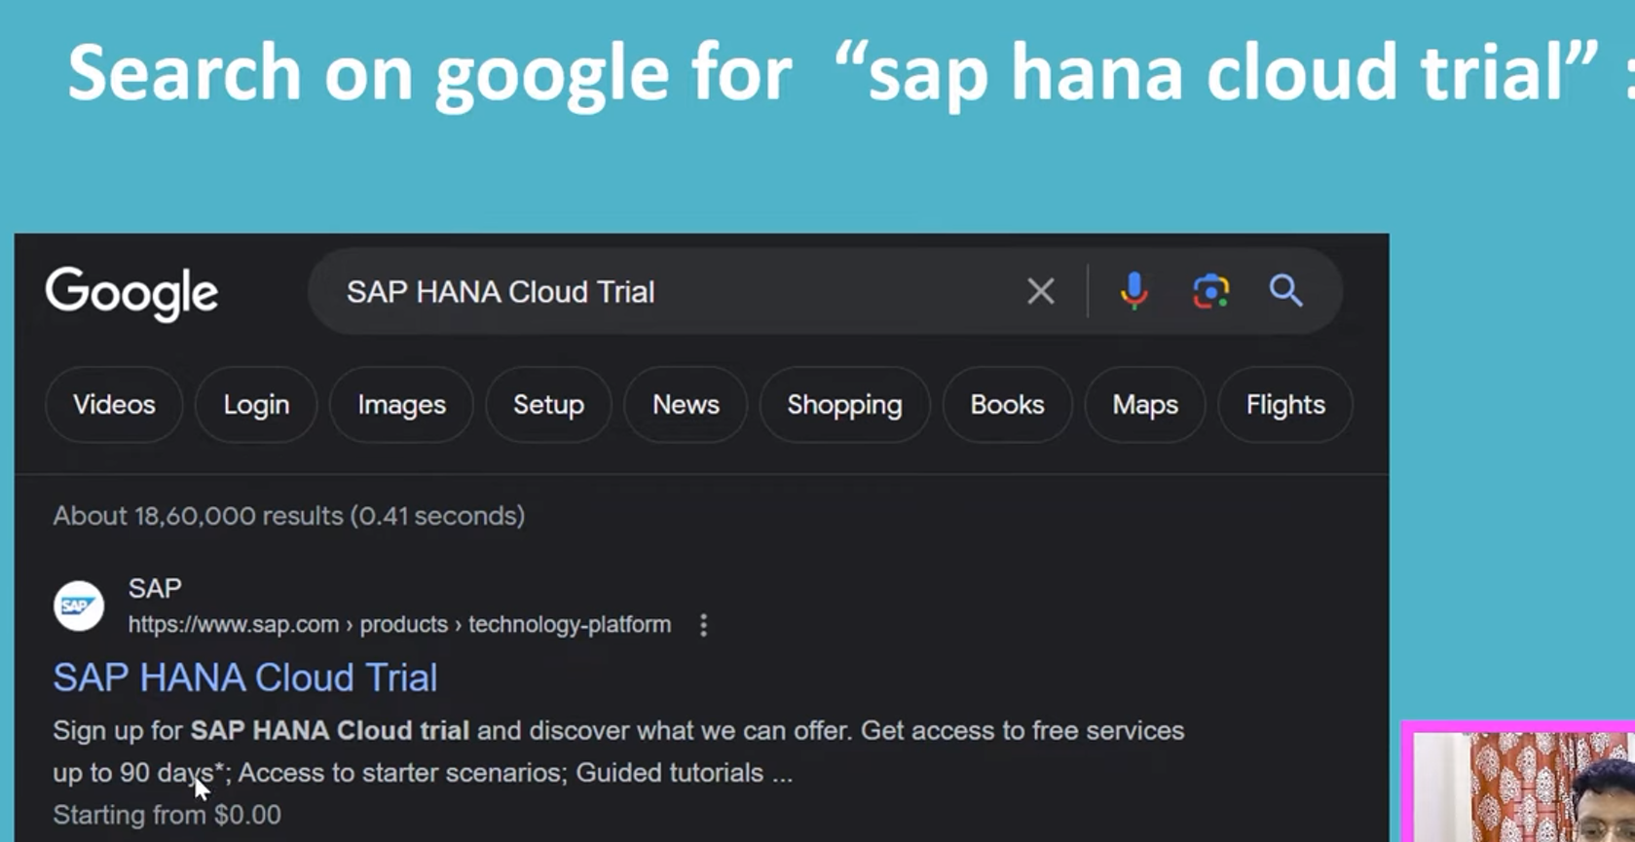  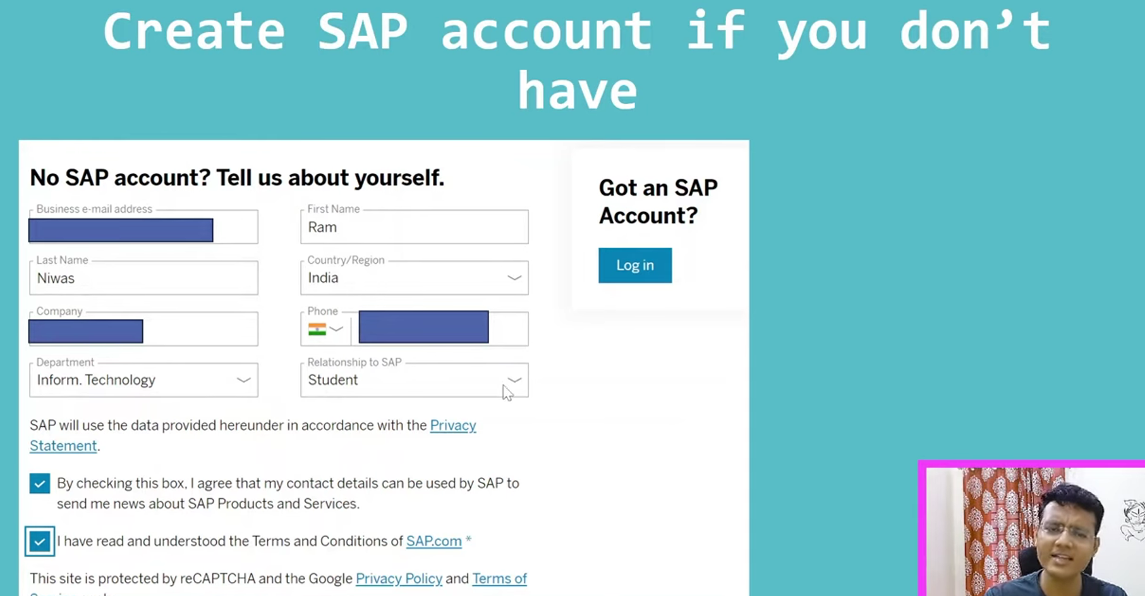 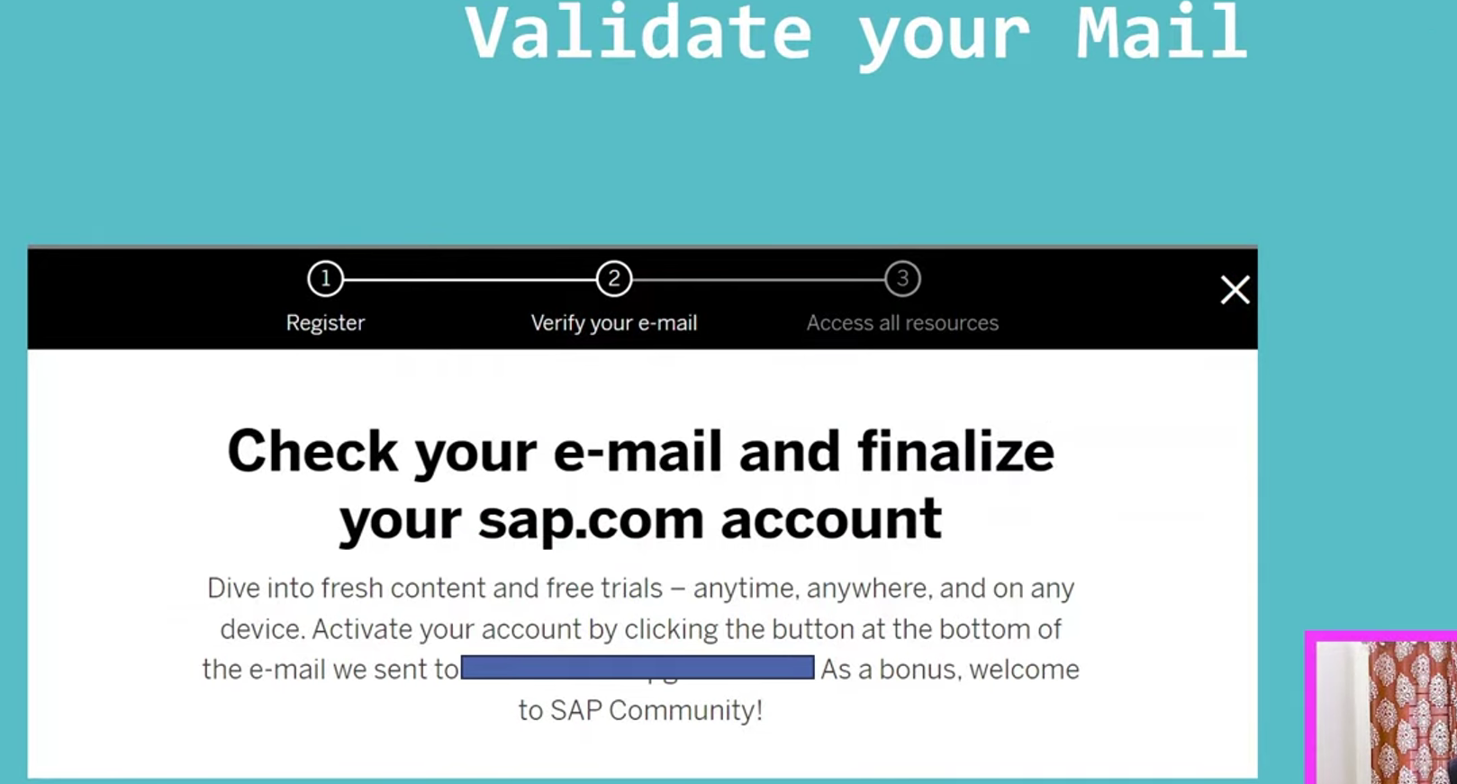

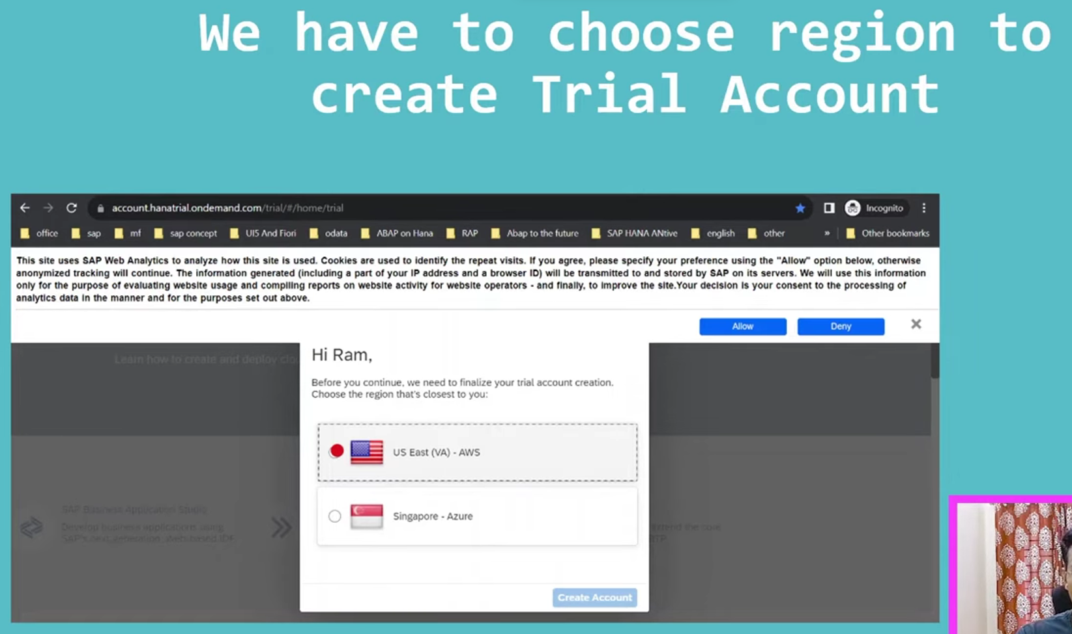

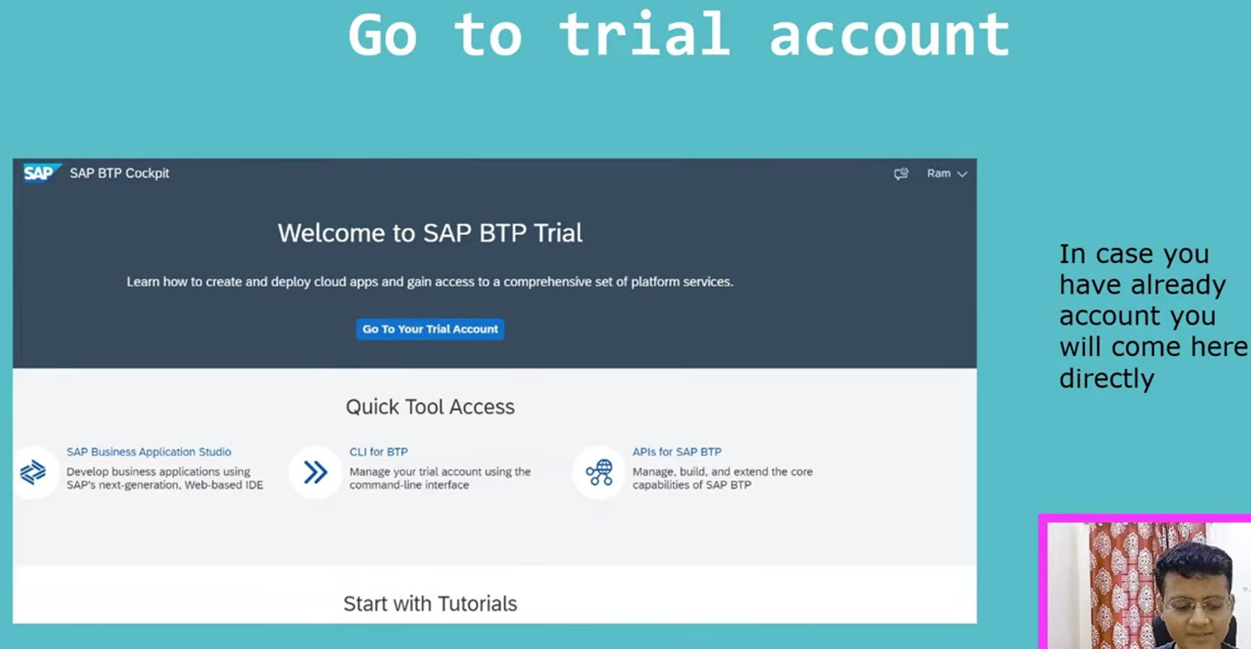 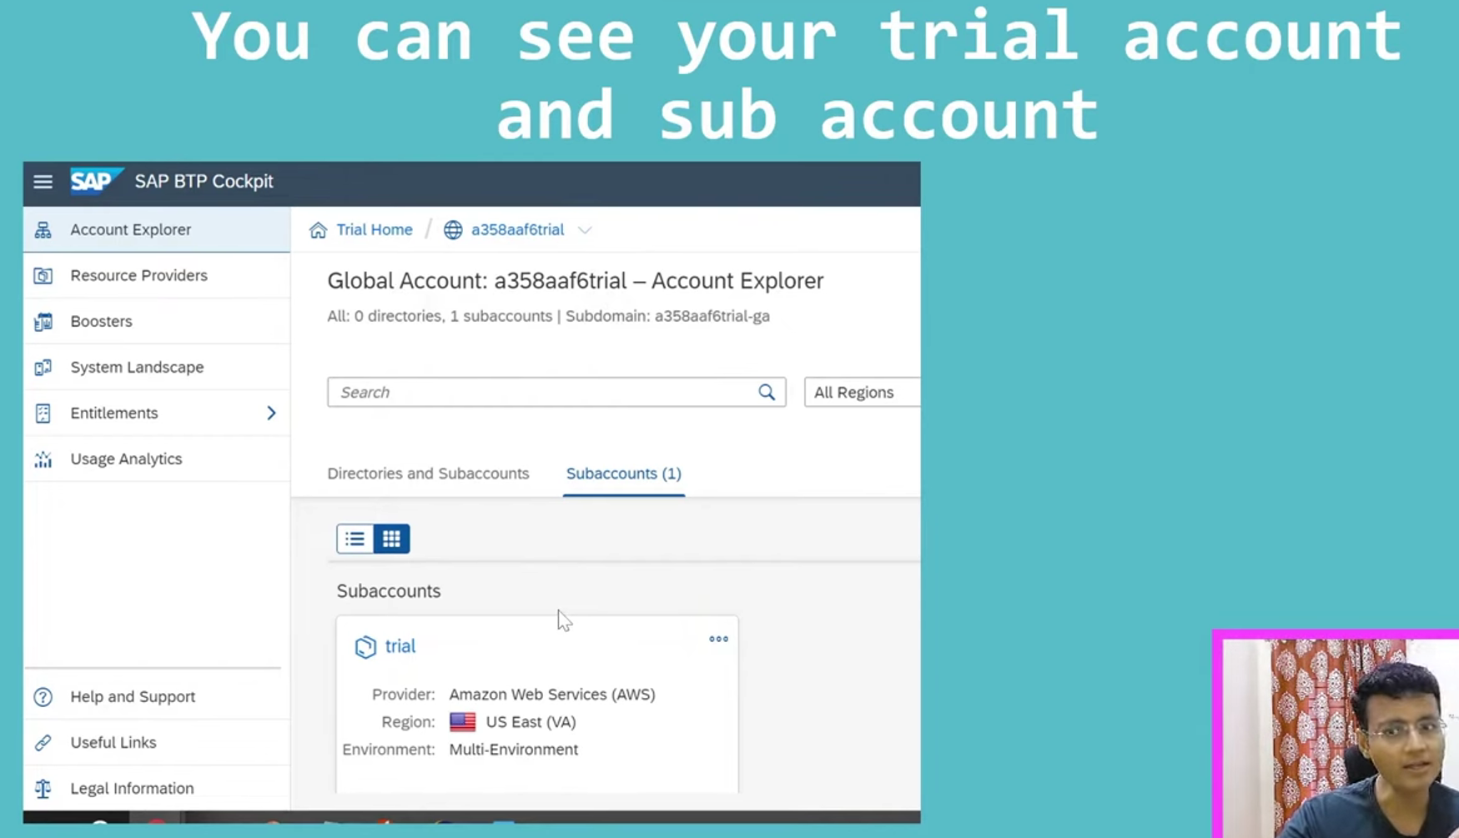

## Add abap instance in ABAP Cloud

1. Go to the trial sub account.
2. Inside trial sub account, go to service market palce 🡪 search for ABAP environment., create the instance for ABAP environment. While creating instance—you have to provide the mail id also.
3. After few steps, it will create the abap instance.
4. Now check the instances in instances and subscriptions tab.
5. To access this abap instance in Eclispse, we need to create the service key.
6. Now create the service key. – go to instances tab – click on ‘ . . .’ button 🡪 click on service key button.
7. Once service key created, now download the service key. 🡪 this will be useful in eclipse.

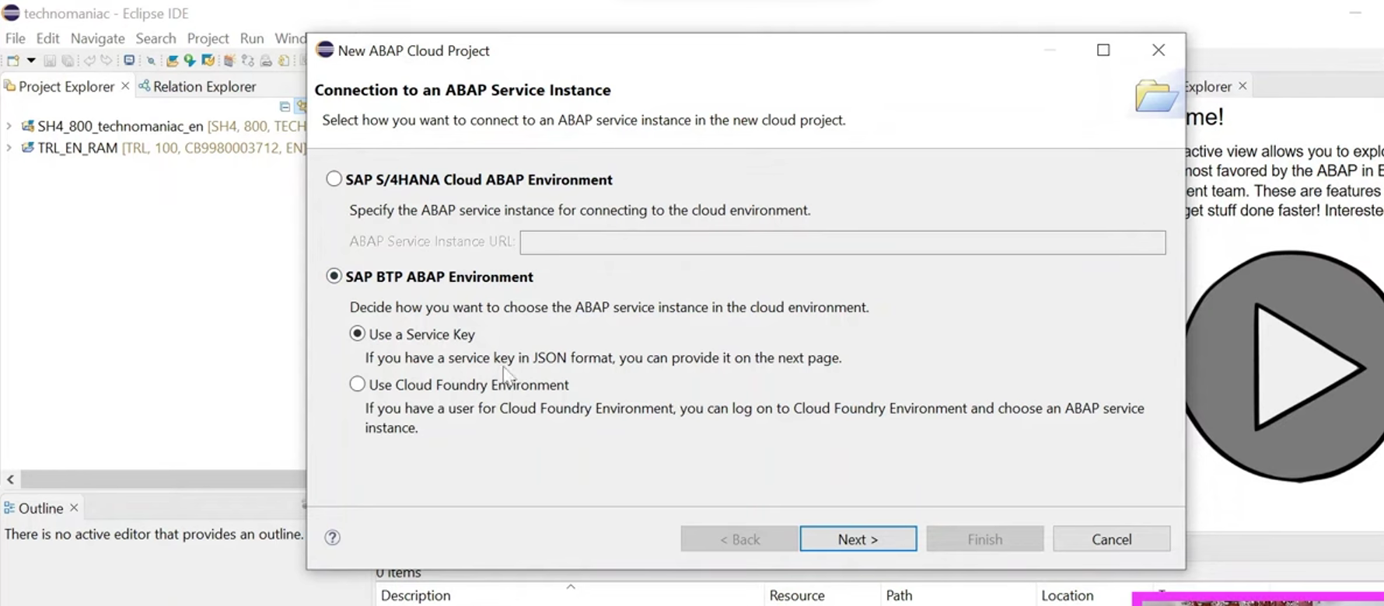

Import the service key.

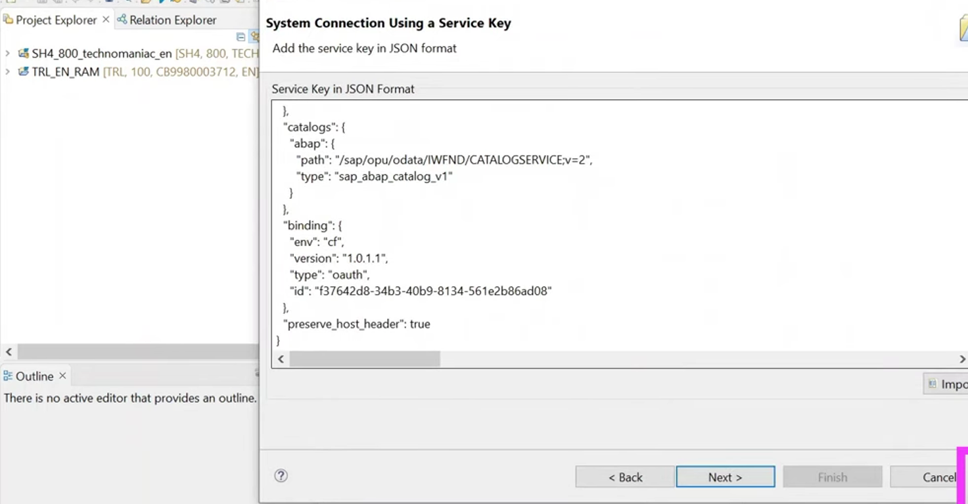

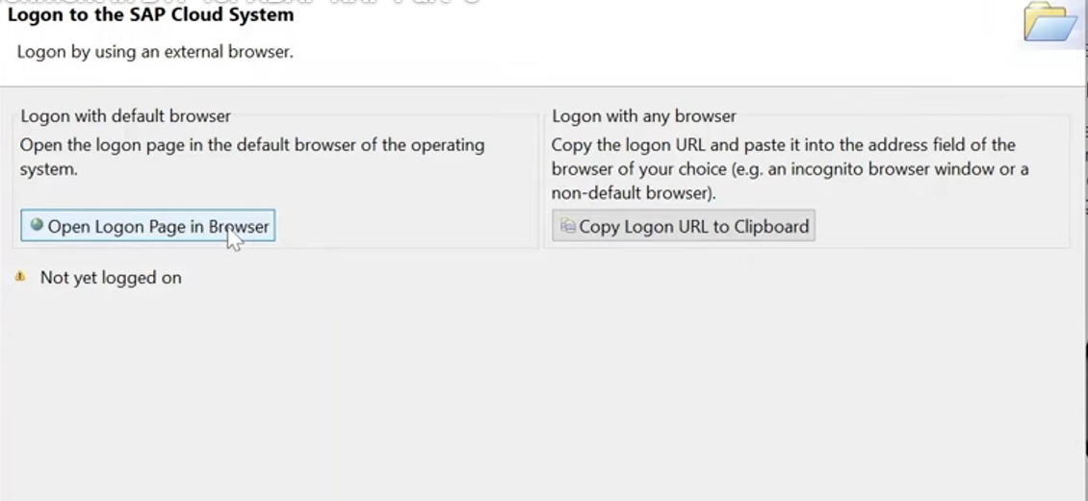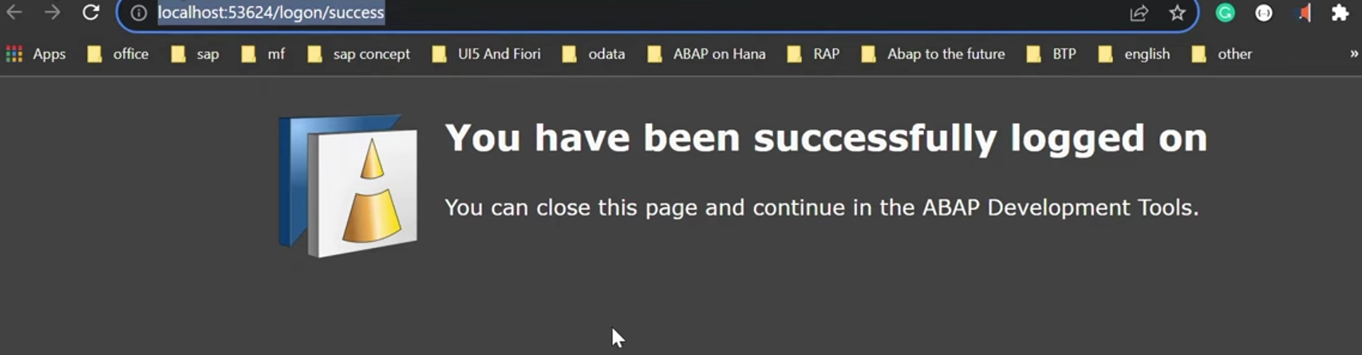

After successfully logged in, we have to add ADT plugins.

Once done then create the package to start our developments.